

| Business Template  **Power BI Final Project** |
| --- |
|  |

**1.1 Business Background** **3**

**1.2 Report Blueprint (Power BI Desktop)** **4**

Visual Style (apply consistently) 4

Pages & Navigation 5

Model (Star Schema) 9

Requirements(Fulfilled) 10

## **1.1 Business Background**

**Company name:** *Jackpot Insights, LLC*

**Logo idea:** 

**Industry:** Data analytics and business intelligence for the Texas lottery sector — focusing on sales, retailer performance, customer insights, and game trends..

**Business process analyzed:** The business process is the **end-to-end lottery sales** in Texas — from ticket sales (Scratch and Non-Scratch) to payouts, retailer profits, and customer win patterns. The report analyzes sales trends, retailer performance by geography, customer demographics, and game profitability over time. It also provides drill-through capability for granular retailer-level insights.

**Purpose of the report:**

* Identify sales trends and spikes (e.g., early 2022 anomaly).
* Compare Scratch vs. Non-Scratch game profitability.
* Spot top and bottom performing retailers.
* Understand customer win patterns and payout behavior.
* Optimize sales targets and marketing strategies based on geographic and demographic patterns.

**Primary end users:**

* **Lottery Commission executives** – to monitor sales performance and payouts.
* **Retailer management teams** – to benchmark profitability and identify improvement opportunities.
* **Marketing teams** – to design targeted campaigns by game type, region, and demographic.
* **Regulatory bodies** – to ensure transparency in lottery operations and payouts.

**Key business questions this report answers:**

1. Which game type (Scratch or Non-Scratch) generates more sales and profit?
2. How do daily sales and payouts change over time, and what caused the spike in early 2022?
3. Which cities and retailers are the most and least profitable?
4. What are the demographic patterns of winning customers?
5. Which payment methods dominate transactions?
6. How does adjusted payout compare to total sales in different games?

**Business Problems Resolved**

* **Lack of centralized visibility** into sales, payouts, and profitability across games and retailers.
* **Inefficient marketing targeting** due to missing demographic and regional breakdowns.
* **Difficulty identifying underperforming retailers** without detailed drill-through analytics.
* **Missed opportunities to improve profitability** through understanding payout ratios and customer behavior.
* **Limited ability to act on sales spikes or anomalies** without timely trend data.

**Grain and scope:** Transaction‑level fact of ticket sales by date, game, customer, employee, retailer, and payment method; time range 2021–2022 with monthly analysis and drillthrough to retailer context.

## **1.2 Report Blueprint (Power BI Desktop)**

### Visual Style (apply consistently)

* **Palette:** Very soft yellow (#F0E199), Vibrant Green (#13FE3A), Light Grey(#E6E6E6), vivid lemon yellow (#F2F60F), pale blue (#DEEFFF), cotton candy pink(#F3B4DC), neutral grey(#CCCCCC)
* **Fonts:** Times New Roman(vizualization titles),,Arial(page title), Segoe UI (body), DIN or Bahnschrift (numbers).
* **Header bar:** left = logo, center = page title (dynamic)
* Use clean grids, 8–12px spacing, soft shadows, rounded corners.

### 

### Pages & Navigation

**P1. Lottery Sales Overview (Texas)**

* **KPI cards**: Total payout (7.47M), total tickets sold (2M), total sales (7.98M), sales vs. target (+30.94%).
* **Trend chart**: Daily sales & adjusted payout over time (big spike in early 2022).
* **Category mix**: Donut chart — Scratch (92.64%) vs. Non-Scratch (7.36%) sales.
* **Scratch vs. Draw comparison**:  
  + Tickets sold: Scratch 3.38M vs. Non-Scratch 634.31K.
  + Sales: Scratch 6.71M vs. Non-Scratch 1.27M.

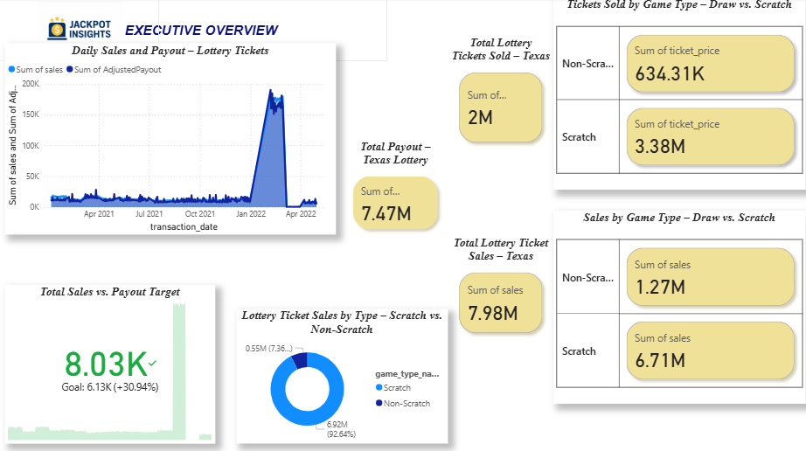

**P2. Game Performance**

* **Trend chart**: Total sales vs. total payout over time by game type (Scratch & Non-Scratch) — big spike in early 2022.
* **KPI cards**:  
  + Total payout: Scratch 6.92M, Non-Scratch 550K.
  + Maximum payout per transaction: Scratch 5K, Non-Scratch 10K.
* **Category mix (sales)**: Pie chart — Scratch Tickets 84.12%, other games each <4%.
* **Category mix (payout)**: Donut chart — Scratch Tickets 92.64%, other games each <7%.

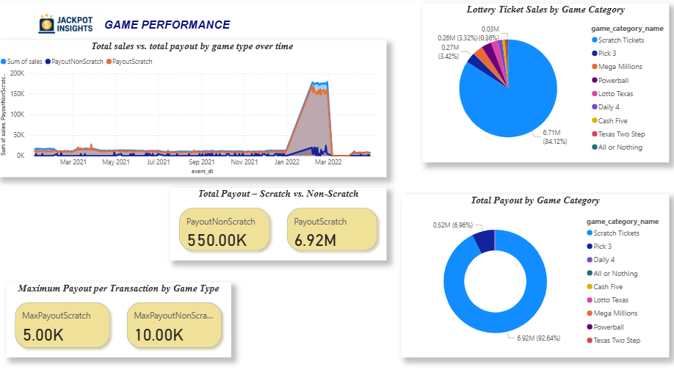

**P3. Retailer & Geography**

* **Map:** Number of retailers by city — concentration in North America, Texas.
* **KPI cards:**
  + City with highest total retailer profit: Port Aransas.
  + Highest total retailer profit value: 505.34K.
* **Table:** City-wise retailer payouts, sales, and profit — top cities sales-wise include El Campo, Alice, Houston; profits vary widely with some negatives.
* **Bubble charts (with drill-through for each bubble to access detailed retailer information):**
  + Top 10 retailers by profit — sales vs. retailer ID (bubble size = profit).
  + Bottom 10 retailers by profit — sales vs. retailer ID (bubble size = profit).

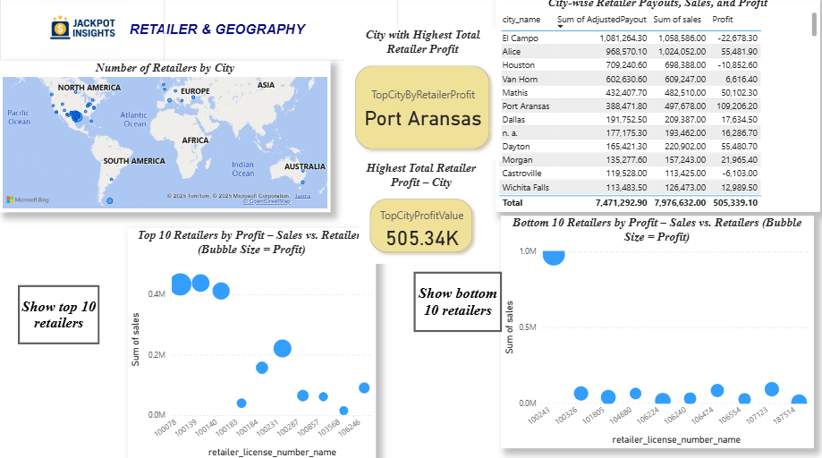

**P4. Customer Insights**

* **Trend chart:** Daily number of winning customers — Scratch vs. Non-Scratch games; stable until late 2021, then a sharp spike in early 2022.
* **KPI cards:**
  + Total winning customers: Scratch 94K, Non-Scratch 107.
  + Average winnings per customer: Scratch 73.90, Non-Scratch 5.14K.
* **Map:** Total sales by customer city — heavy concentration in North America, moderate presence in Europe and other regions.
* **Bar chart:** Customer count by gender — nearly equal male and female representation, with a small share of non-disclosed.
* **Trend chart:** Total average return per ticket by event date — stable pattern until early 2022 spike.

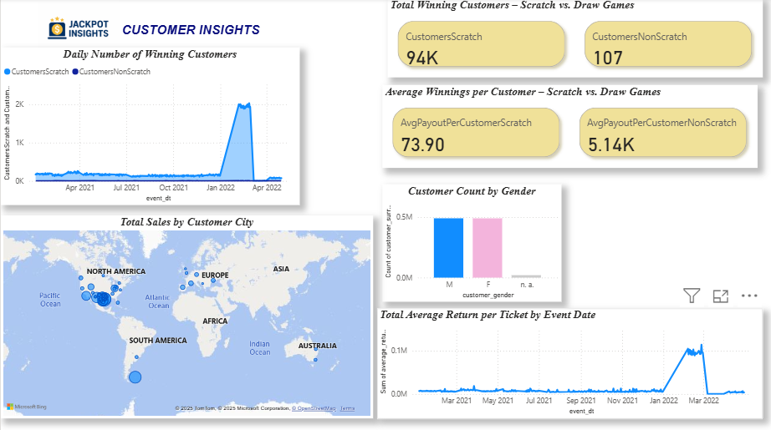

**P5. Drillthrough: Retailer Detail** *(hidden)*:

**Trend chart:** Total sales vs. total payout per day across time for this retailer — consistent pattern with occasional peaks.

* **Double KPI card:** Location name of the retailer and city.
* **KPI cards:**
  + Total sales — overall sales amount.
  + Total customers — number of distinct customers
* **Bar chart:** Payment method distribution — one method dominates, others minimal.

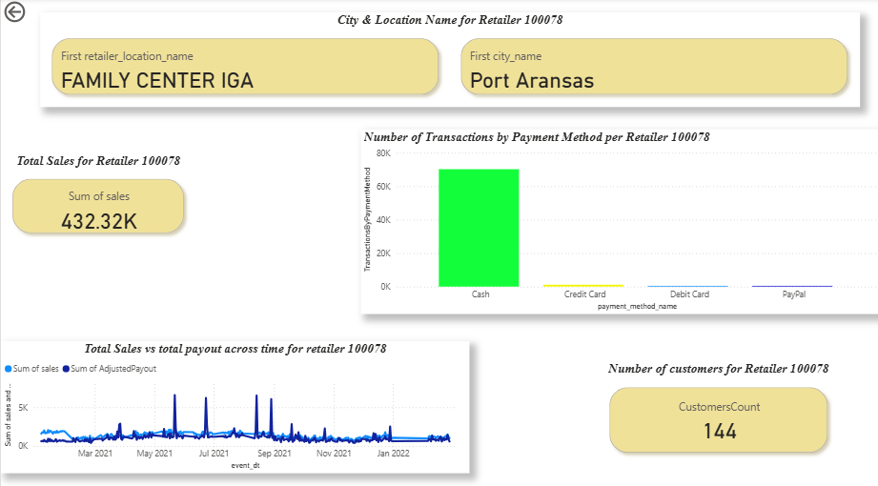

**P6&P7.Tooltip Pages (hidden)**

* **Tooltip 1:** Shows **payment counts** when hovering over the barchart of counts per payment type in the drill-through.  
  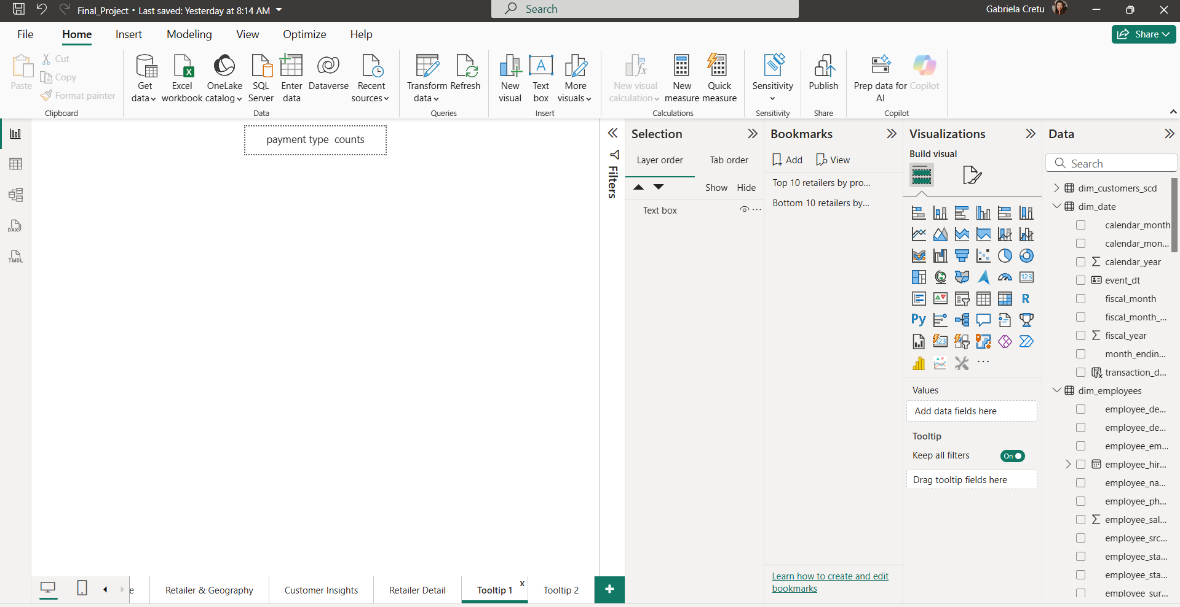
* **Tooltip 2:** Shows **total sales** when hovering over the KPI of total sales in the drill-through.  
  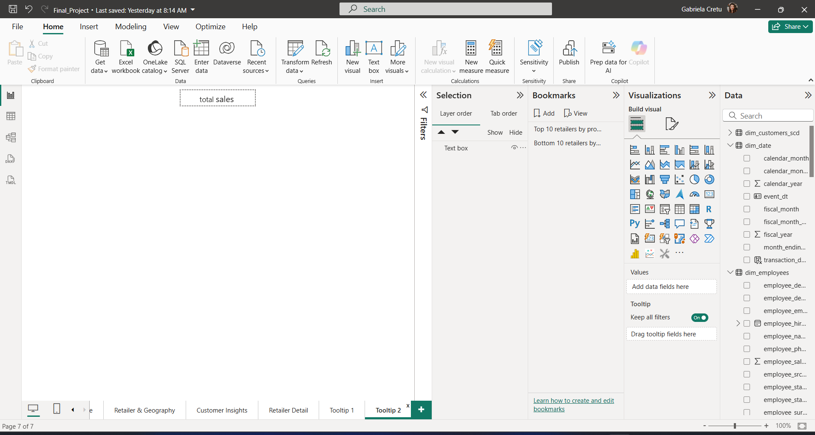

**Navigation:** buttons + page tabs; back and navigator button on all pages; bookmarks for view presets; blank buttons for bookmarks

**Data Preparation (Power Query)**

I imported the fact and dimension tables from my SQL Server Management Studio (SSMS). Prior to this, I had created a new database called **Lottery** in SSMS, into which I imported the dimension tables in CSV format exported from DBeaver. During this import, I defined the primary keys in SSMS for each dimension table.

Once the tables were set up in SSMS, I used Power BI’s import feature to load all the data. Since no transformations were necessary, I directly loaded the tables into the data model. I then reviewed the relationships: most were automatically detected correctly, except for the **date table**. Although I had defined the primary key as DATE type, Power BI did not automatically link the EVENT_DT from **FCT_SALES** to the EVENT_DT in **DIM_DATE**.

### Model (Star Schema)

* **Fact:** FCT_SALES — keys to Date, Game, Customer, Employee, Retailer, Payment; measures: Sales, Tickets_Bought, Payout.
* **Dims:** DIM_DATE, DIM_GAME_NUMBERS, DIM_CUSTOMERS_SCD, DIM_EMPLOYEES, DIM_RETAILER_LICENSE_NUMBERS, DIM_PAYMENT_METHODS.
* Relationships: *1:*many from each Dim to Fact (single direction, filter from Dim → Fact). Mark DIM_DATE table as Date table using EVENT_DT/DATE.

### Requirements(Fulfilled)

I initially designed a header with the page title and company logo to clearly show each page’s sales focus—whether through an executive overview, retailer and geography insights, customer data, or game performance.

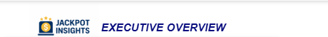







In this report I considered multiple unhidden pages including the dillthrough page and 2 hidden pages for the tooltips.



I implemented best practices, including buttons for accessing bookmarks, drill-throughs to explore specific retailer characteristics from a scatter bubble chart, navigation buttons to return to previous pages, and an overall navigator button.



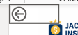

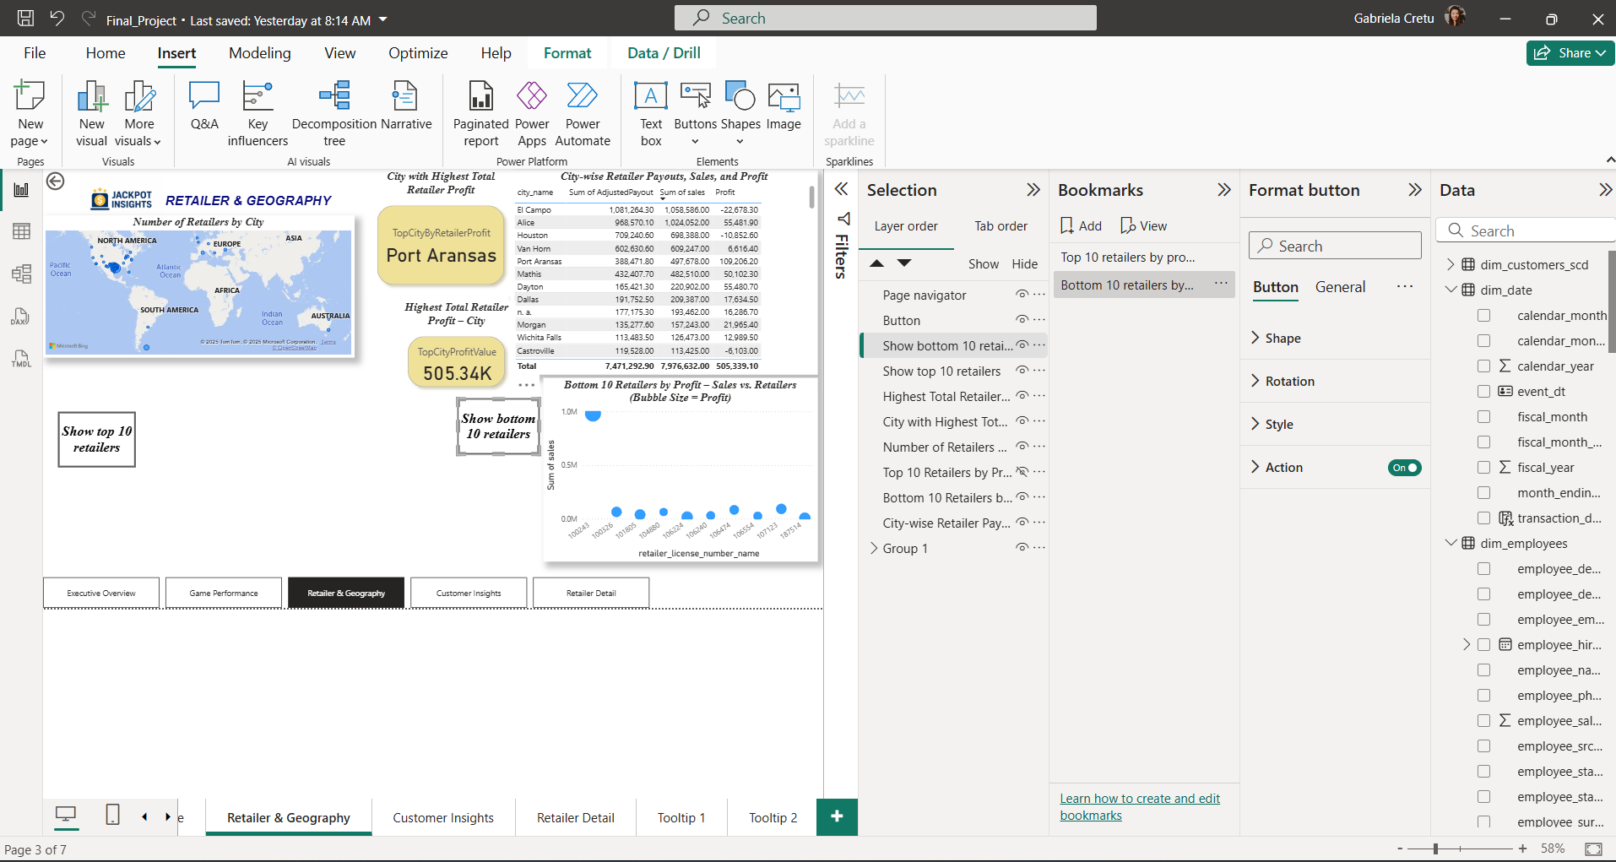

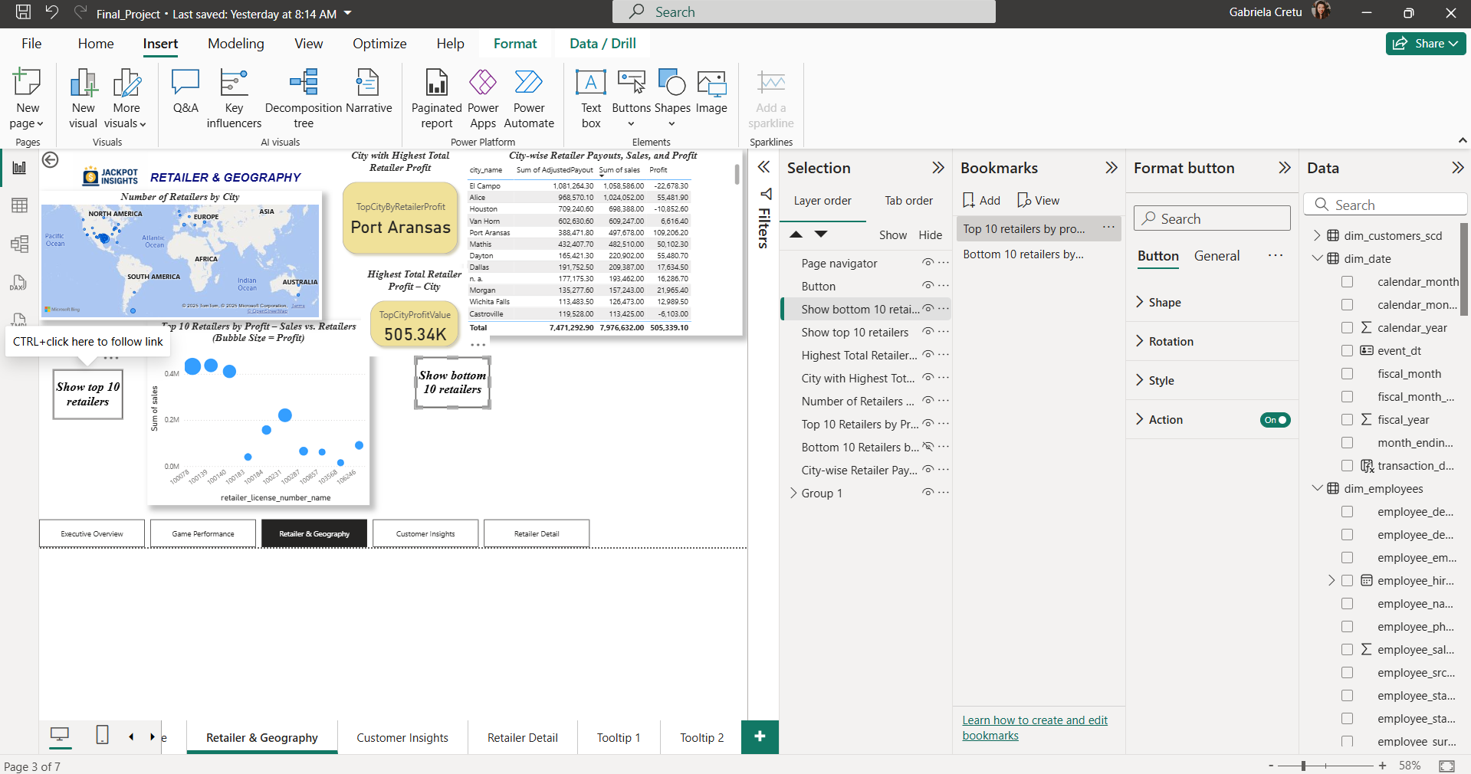

As mentioned earlier, I implemented buttons and two bookmarks to view the top and bottom retailers by profit. Additionally, we included two tooltips on the drill-through page to display total sales and highlight bars in the bar chart showing payment distribution across transactions.  
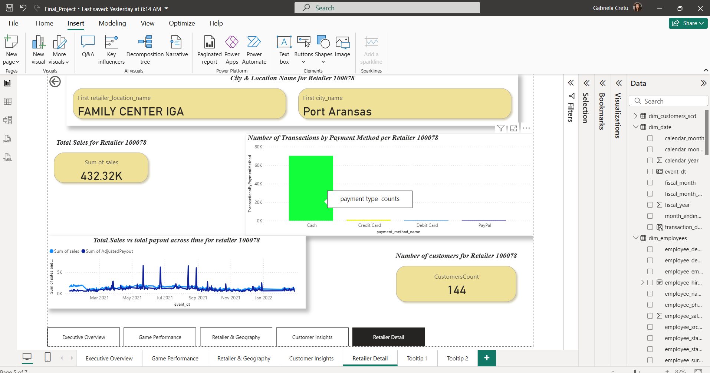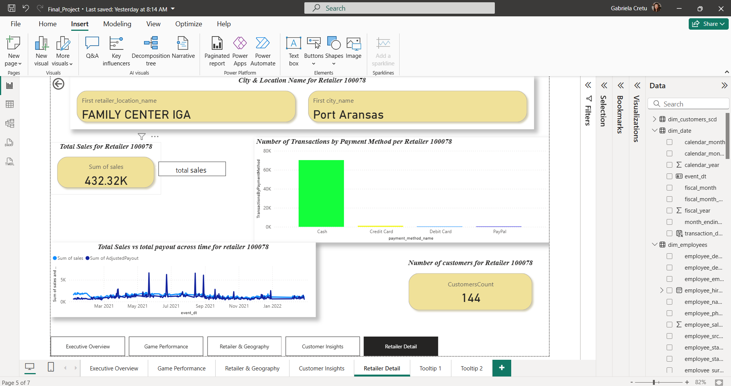

After establishing the correct relationships, I added two calculated columns to **FCT_SALES**:

1. **AdjustedPayout** – to account for adjustments in scratch game payouts and make them realistic.  
   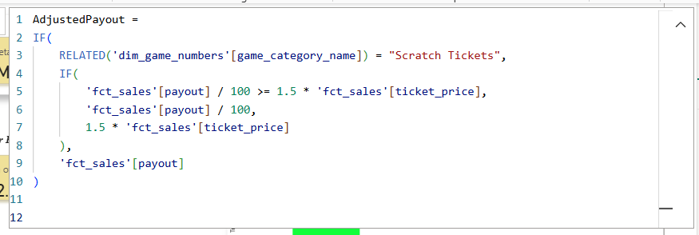
2. **AverageReturnPerTicket** – to evaluate whether purchasing more tickets affects the average return and, implicitly, the winning probability.



After adding the calculated columns, i defined my measures.

1. **Payout Measures(PayoutNonScratch & PayoutScratch)**
   * We created a DAX measure called **PayoutNonScratch** that sums payouts over the entire table while filtering out games categorized as “scratch.”
   * This allows us to analyze how the total payouts for non-scratch games differ from scratch or instant win games.
   * Similar to the first measure, but this time we filter to include only scratch games- **PayoutScratch**

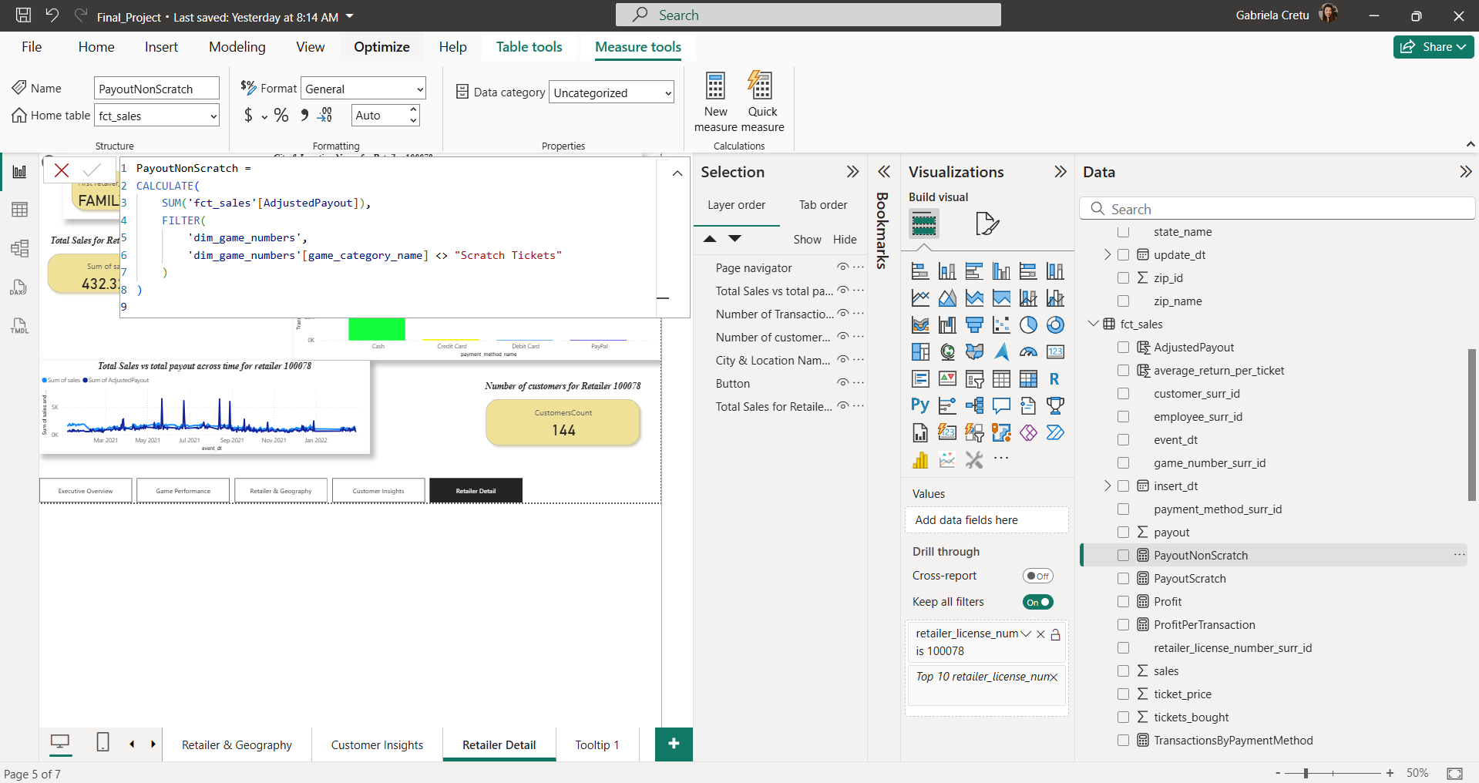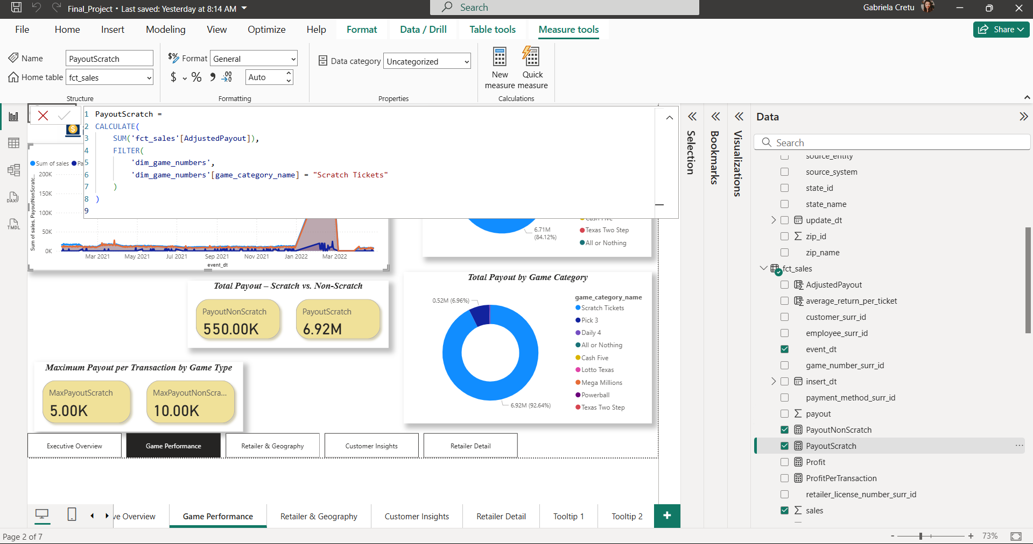

1. **Aggregated Payout Measures(MaxPayoutNonScratch & MaxPayoutScratch)**
   * We created two max aggregation DAX measures: one for non-scratch games and one for scratch games in order to display the highest possible payout by game type.

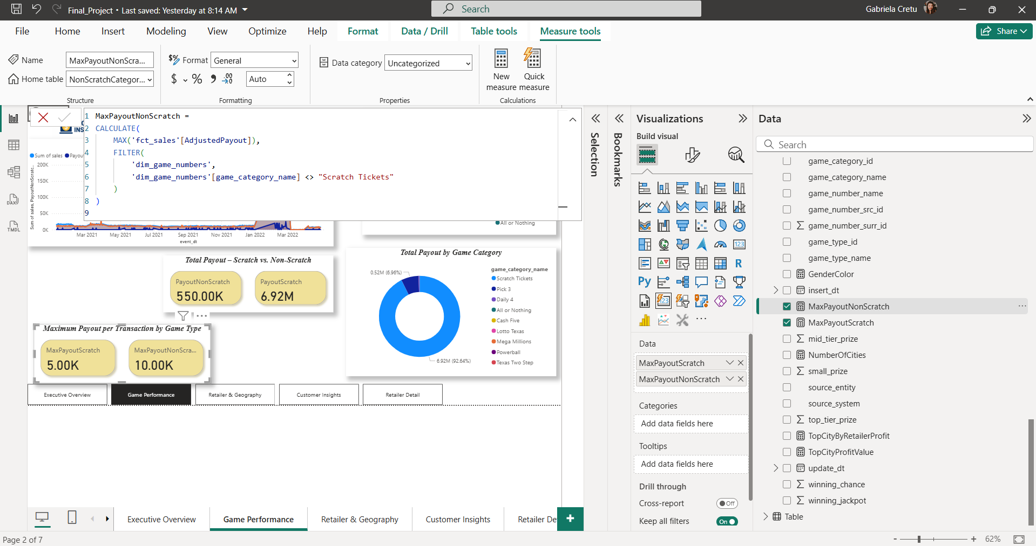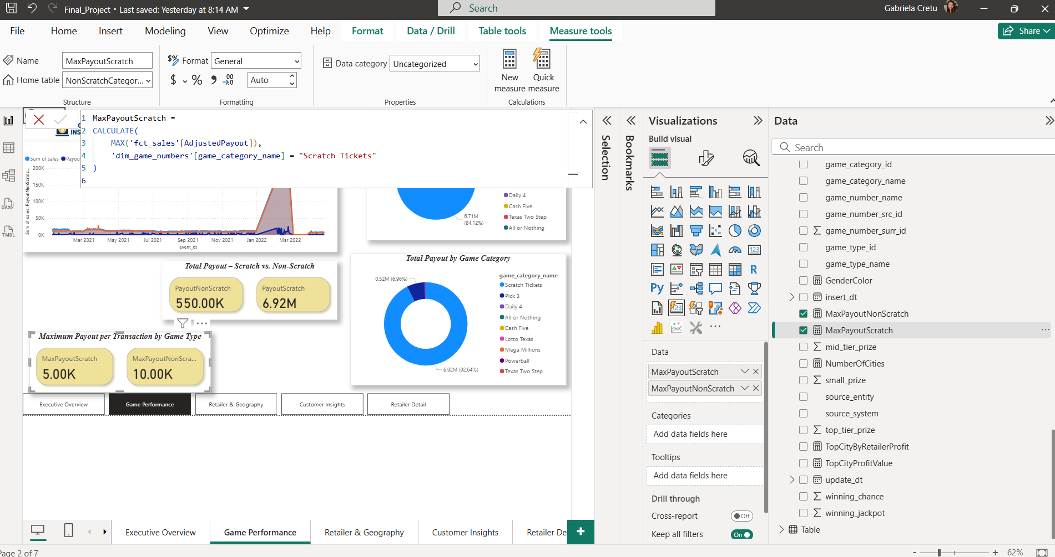

1. **Profit Measure**
   * A DAX measure was defined to calculate total profit by summing all sales and subtracting the adjusted payout.

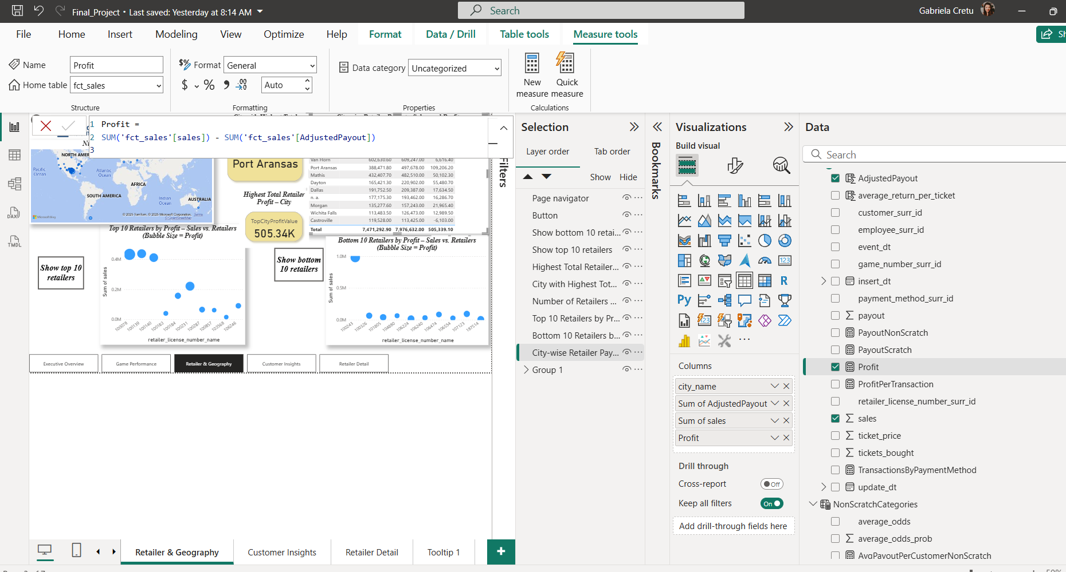

1. **Most profitable city (TopCityByRetailerProfit & TopCityProfitValue)**
   * We created a measure to identify which city generates the most profit based on the retailers profit residing there(**TopCityByRetailerProfit).**
   * An additional measure displays the value of the top city’s profit, providing more context(**TopCityProfitValue).**

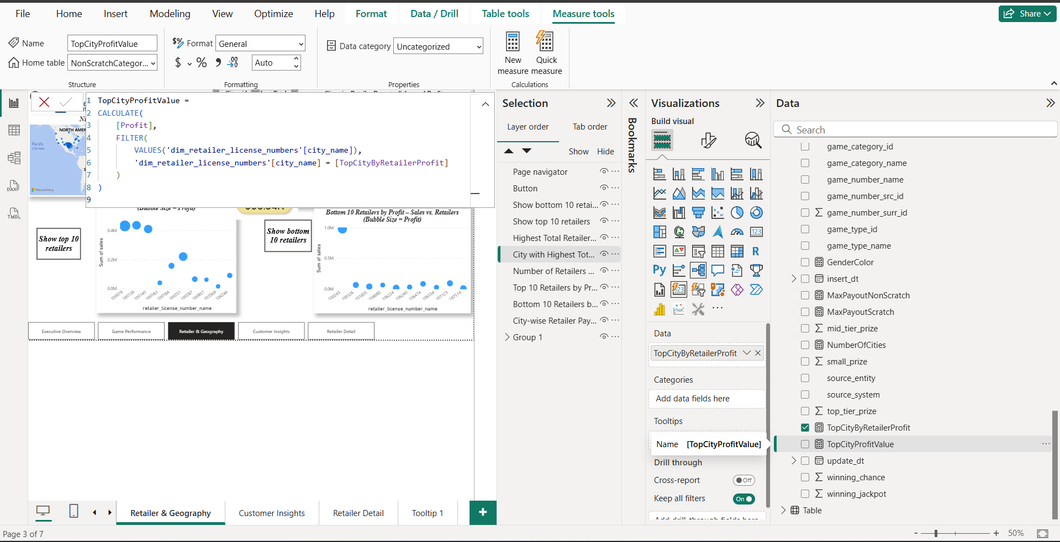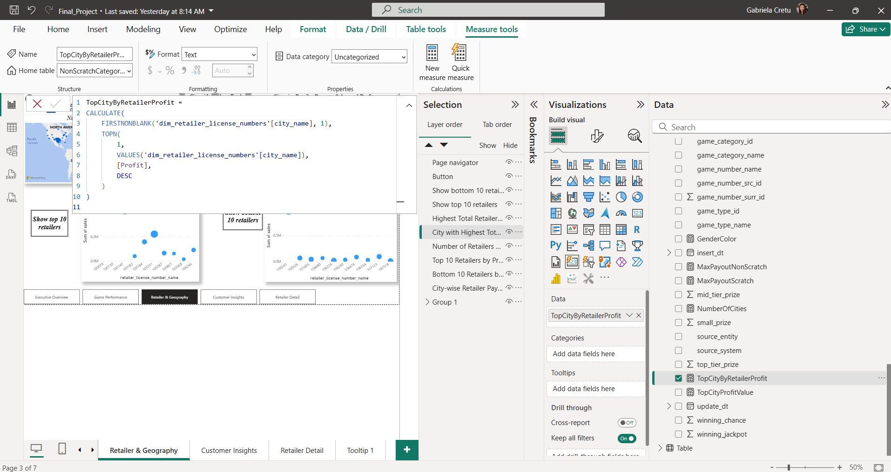

1. **Number of Winners Measures(CustomersScratch & CustomersNonScratch)**
   * Two new measures were defined:  
     + CustomersScratch: counts winners in scratch games
     + CustomersNonScratch: counts winners in non-scratch games
   * This analysis helps determine which games generate more wins (and therefore less revenue for retailers), influencing customer betting behavior.

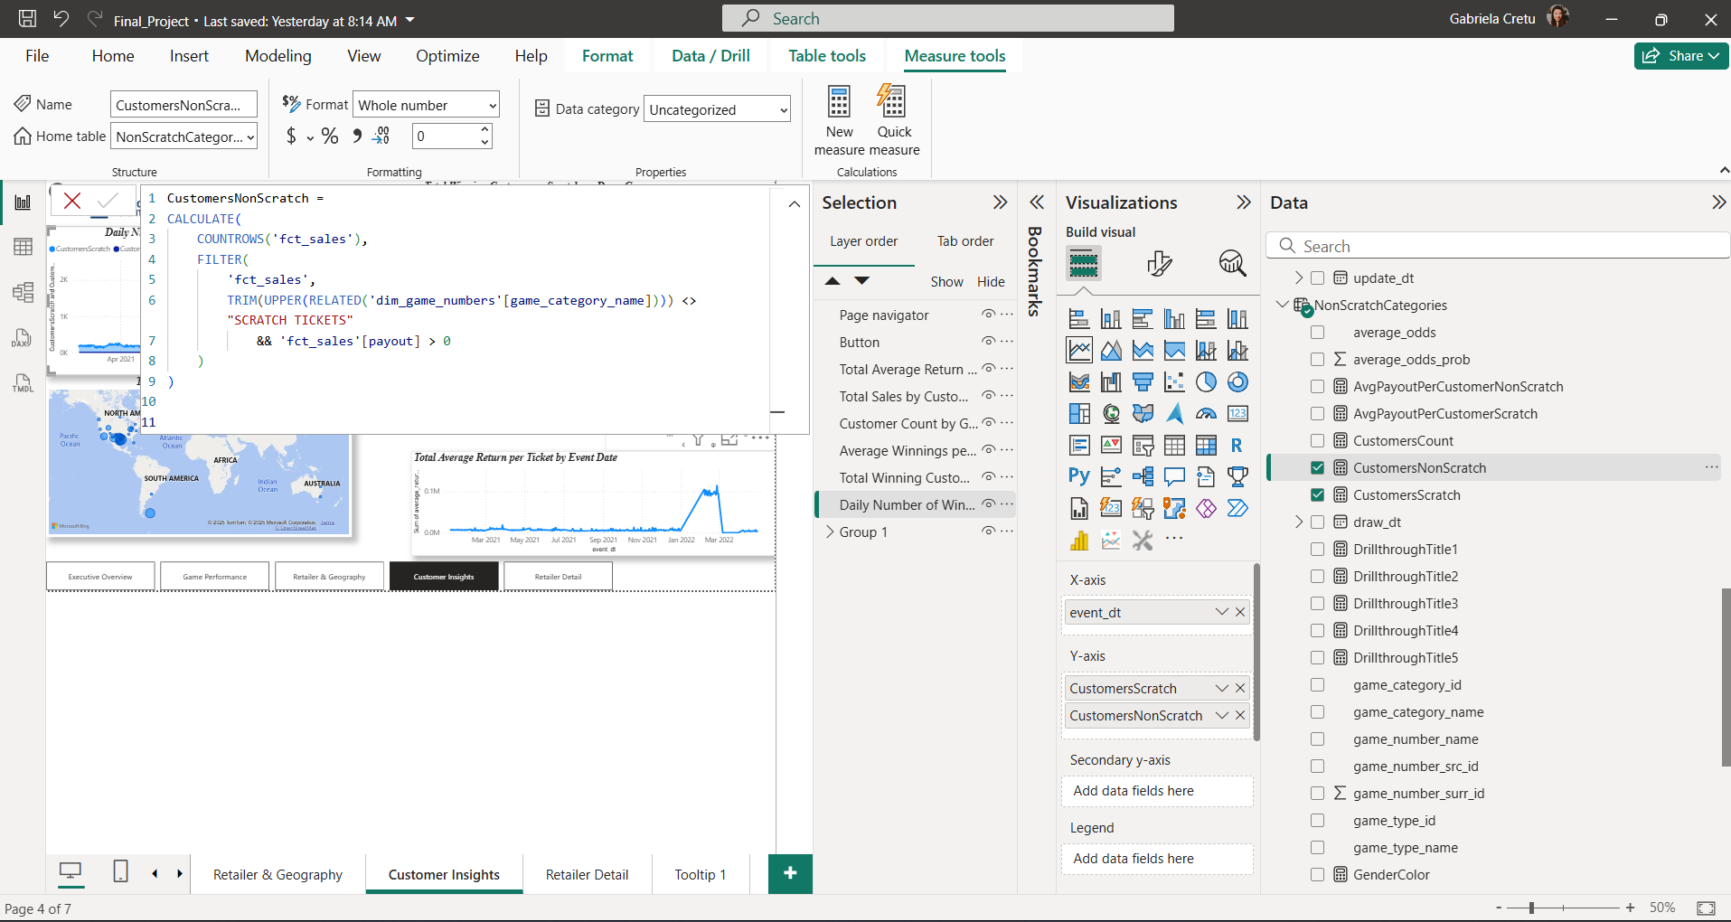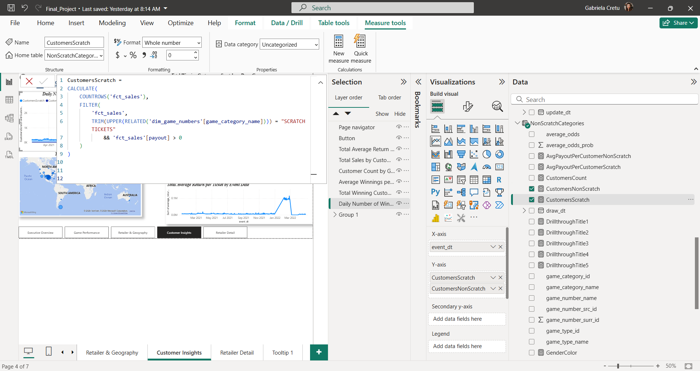

1. **Average Payout per Customer(AvgPayoutPerCustomerNonScratch  
   & AvgPayoutPerCustomerScratch)**
   * Two measures were created to calculate the average payout per winning customer:  
     + AvgPayoutPerCustomerNonScratch
     + AvgPayoutPerCustomerScratch
   * This allows a deeper understanding of customer winnings by game type.

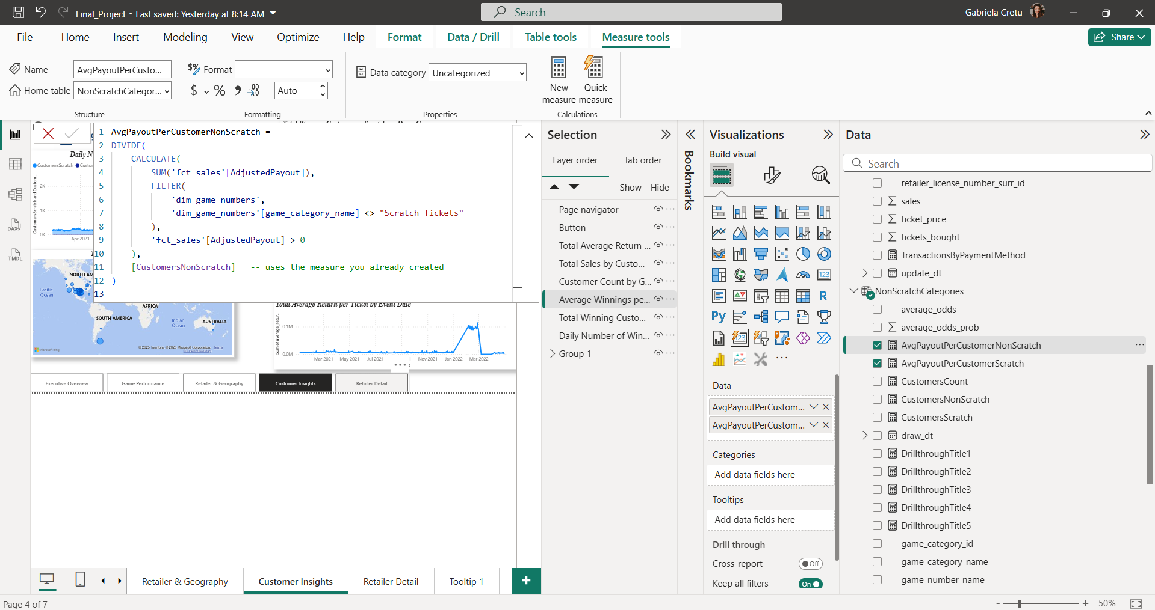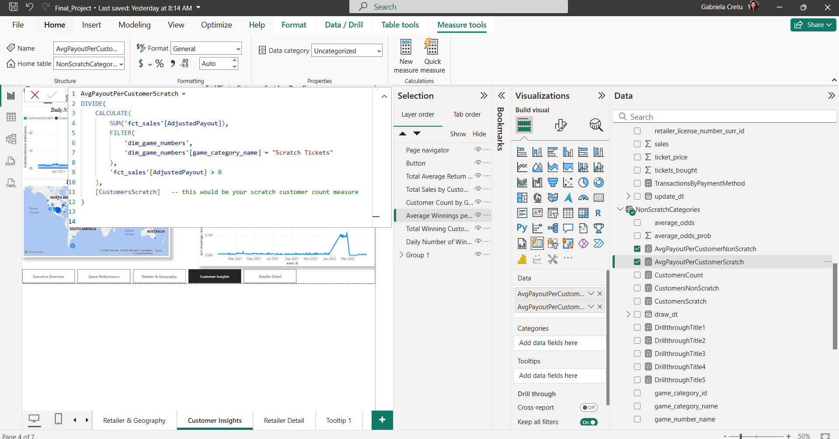

1. **Transactions by Payment Method(TransactionByPaymentMethod)**
   * A measure was defined to track the number of transactions per payment method for each retailer.

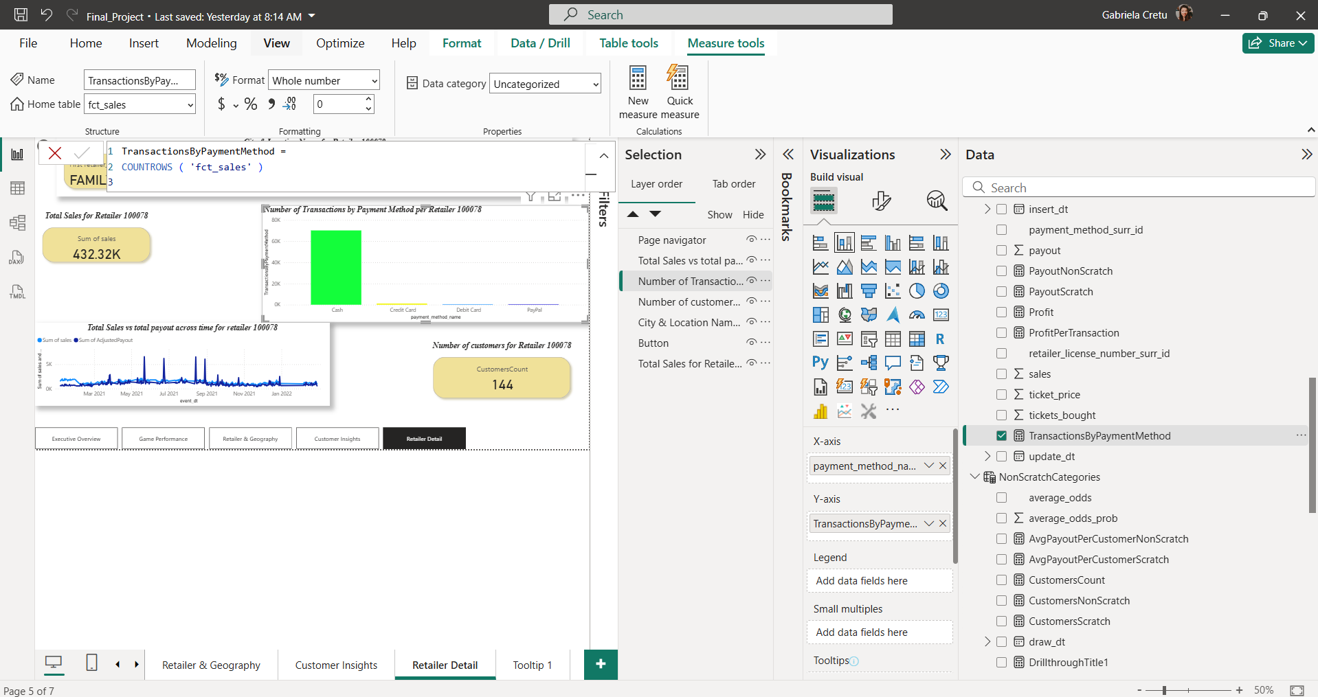

1. **Unique Customer Count (SCD Type 2 Handling)(CustomersCount)**
   * To account for slowly changing dimensions (type 2) in the customer table, we defined a measure CustomersCount.
   * This uses DISTINCTCOUNT on the customer_src_id column to count unique customers per retailer over time, rather than relying on surrogate keys.

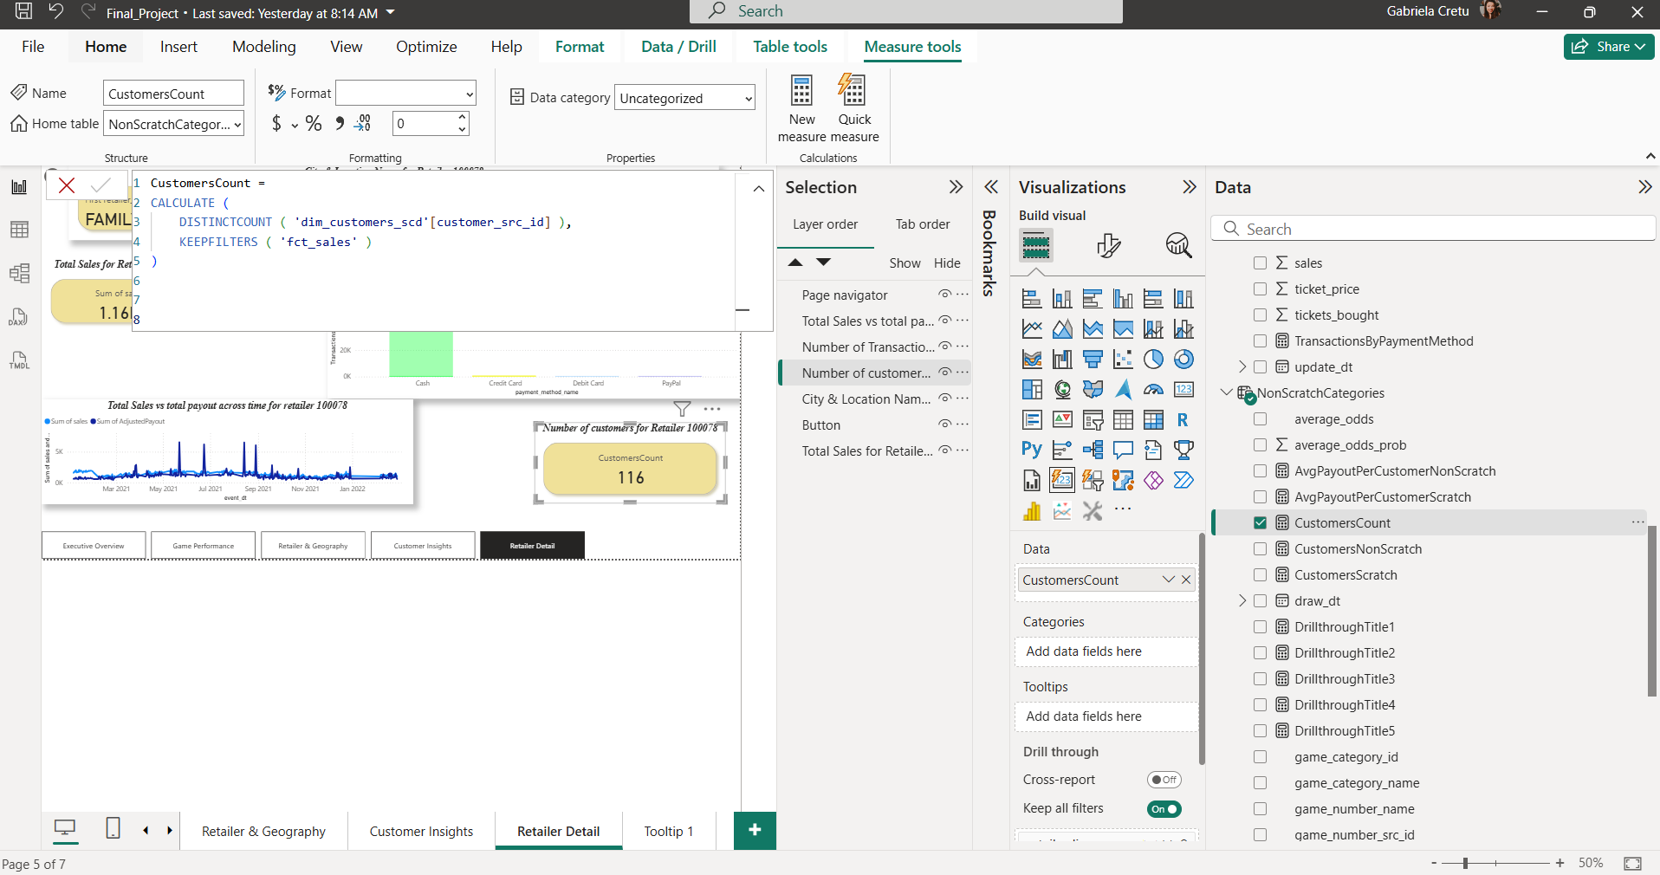

I also implemented dynamic visualization titles. When setting up the drill-throughs for each bubble in my scatter plots of the top 10 and bottom 10 retailers by profit, I noticed that the retailer’s name was missing when viewing specific characteristics. To address this, I created a dynamic title that automatically updates to match the corresponding retailer during drill-through. This feature was applied to every visualization on the drill-through page.

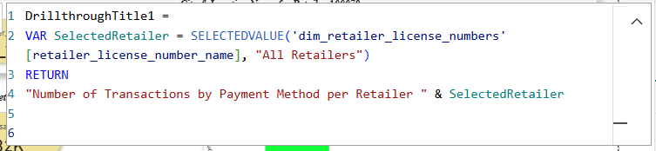

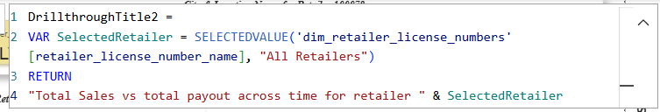

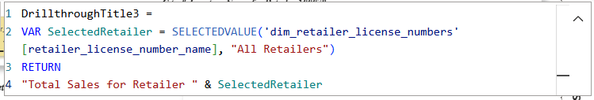

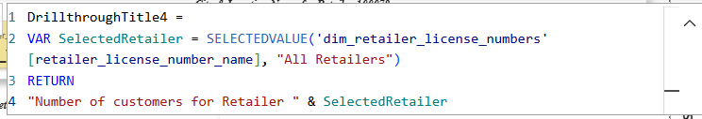

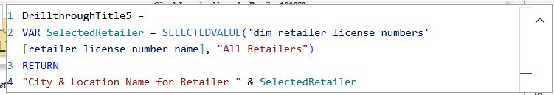

As mentioned earlier, I implemented a drill-through feature, which provides deeper insight into a specific entity—in this case, a retailer represented by a bubble in my scatter plots. By right-clicking on a bubble, you can access the drill-through option, which takes you to a new page containing detailed information about that retailer. Since I introduced this feature earlier, I won’t go into further detail here.

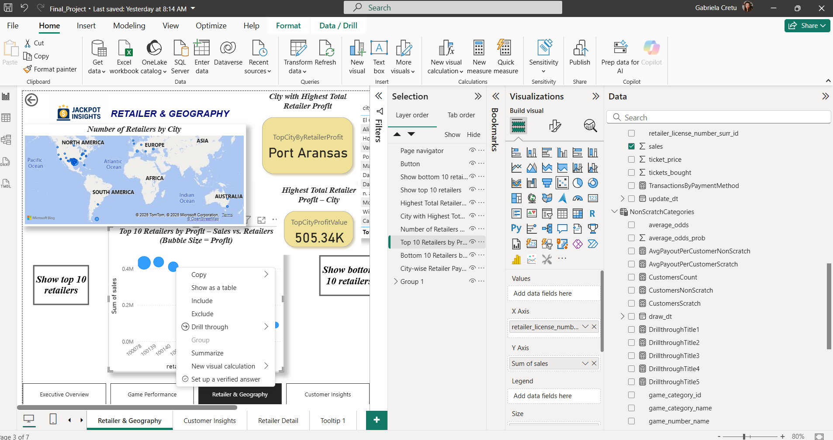

The next step was applying conditional formatting to two bar chart visuals—one on the Customers page and the other on the Drill-through page. Initially, both charts used the same colors for all columns, making it difficult to visually distinguish payment types in the Drill-through chart or genders in the Customers chart. To resolve this, I applied conditional formatting for clearer visual differentiation.

